**SQL QUERIES TO EXTRACT KEY INSIGHTS FROM COVID 19 DATA SET**

1. Exploring Total cases VS total deaths and finding out the likelihood of people dying if they contract covid

Select Location, date, total_cases, total_deaths, (total_deaths/total_cases)*100 AS DeathPercentage

From SQLProject..CovidDeaths

Where location like '%states%'

and continent is not null

order by 1,2

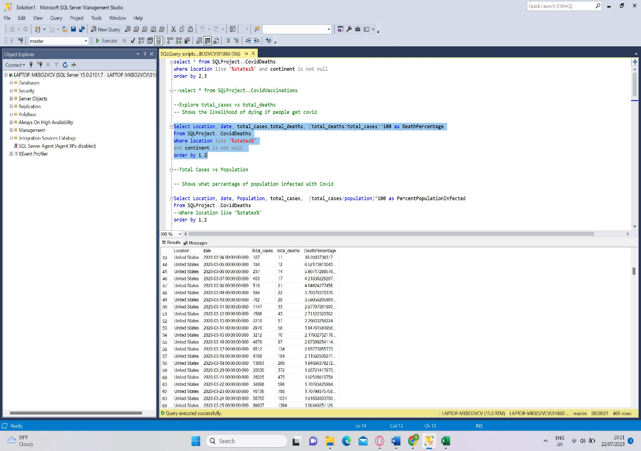

1. Showing what percentage of population is infected by Covid

Select Location, date, Population, total_cases, (total_cases/population)*100 as PercentPopulationInfected

From SQLProject..CovidDeaths

order by 1,2

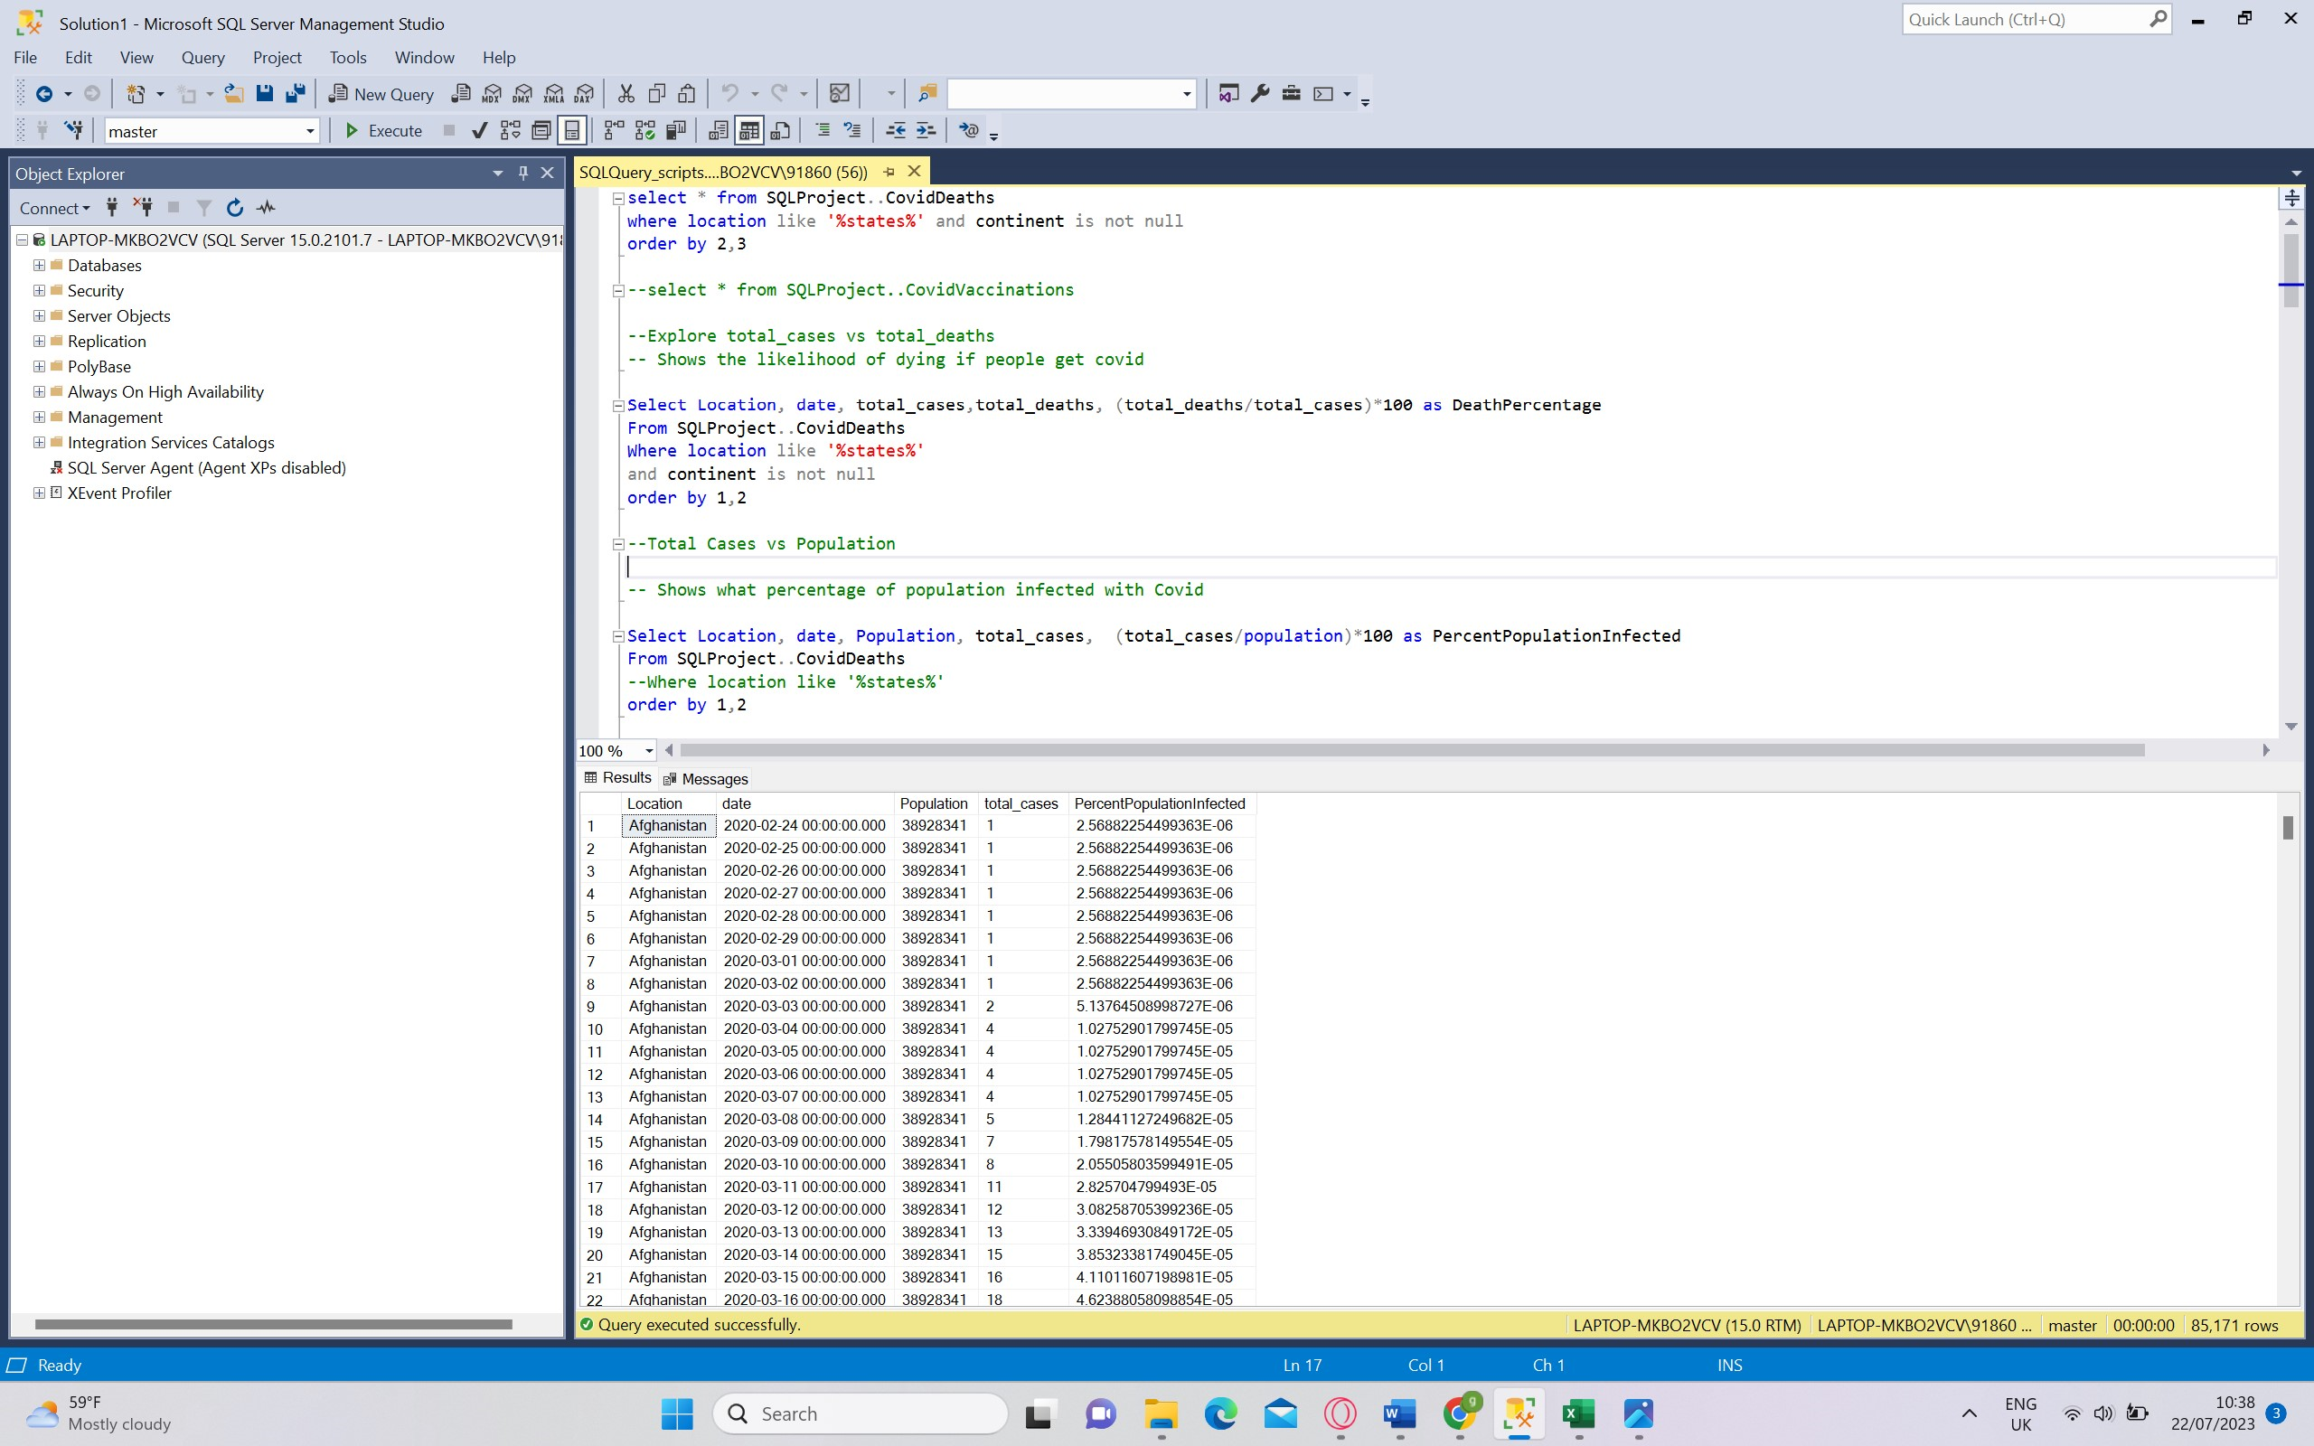

1. What would be the infection rate, list out countries with highest infection rate

Select Location,Population, MAX(total_cases) as HighestInfectionCounts, MAX((total_cases/population))*100 as PercentPopulationInfected

From SQLProject..CovidDeaths

where total_cases is not null

Group by location, Population

order by PercentPopulationInfected desc

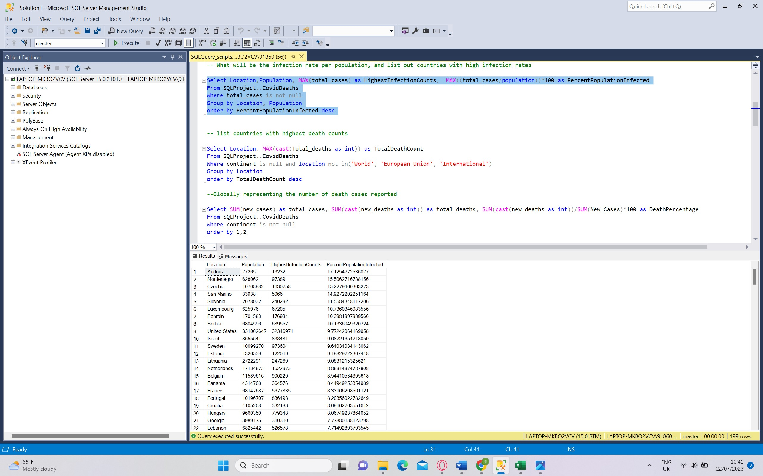

1. List out countries with highest infection death counts

Select Location, MAX(cast(Total_deaths as int)) as TotalDeathCount

From SQLProject..CovidDeaths

Where continent is null and location not in('World', 'European Union', 'International')

Group by Location

order by TotalDeathCount desc

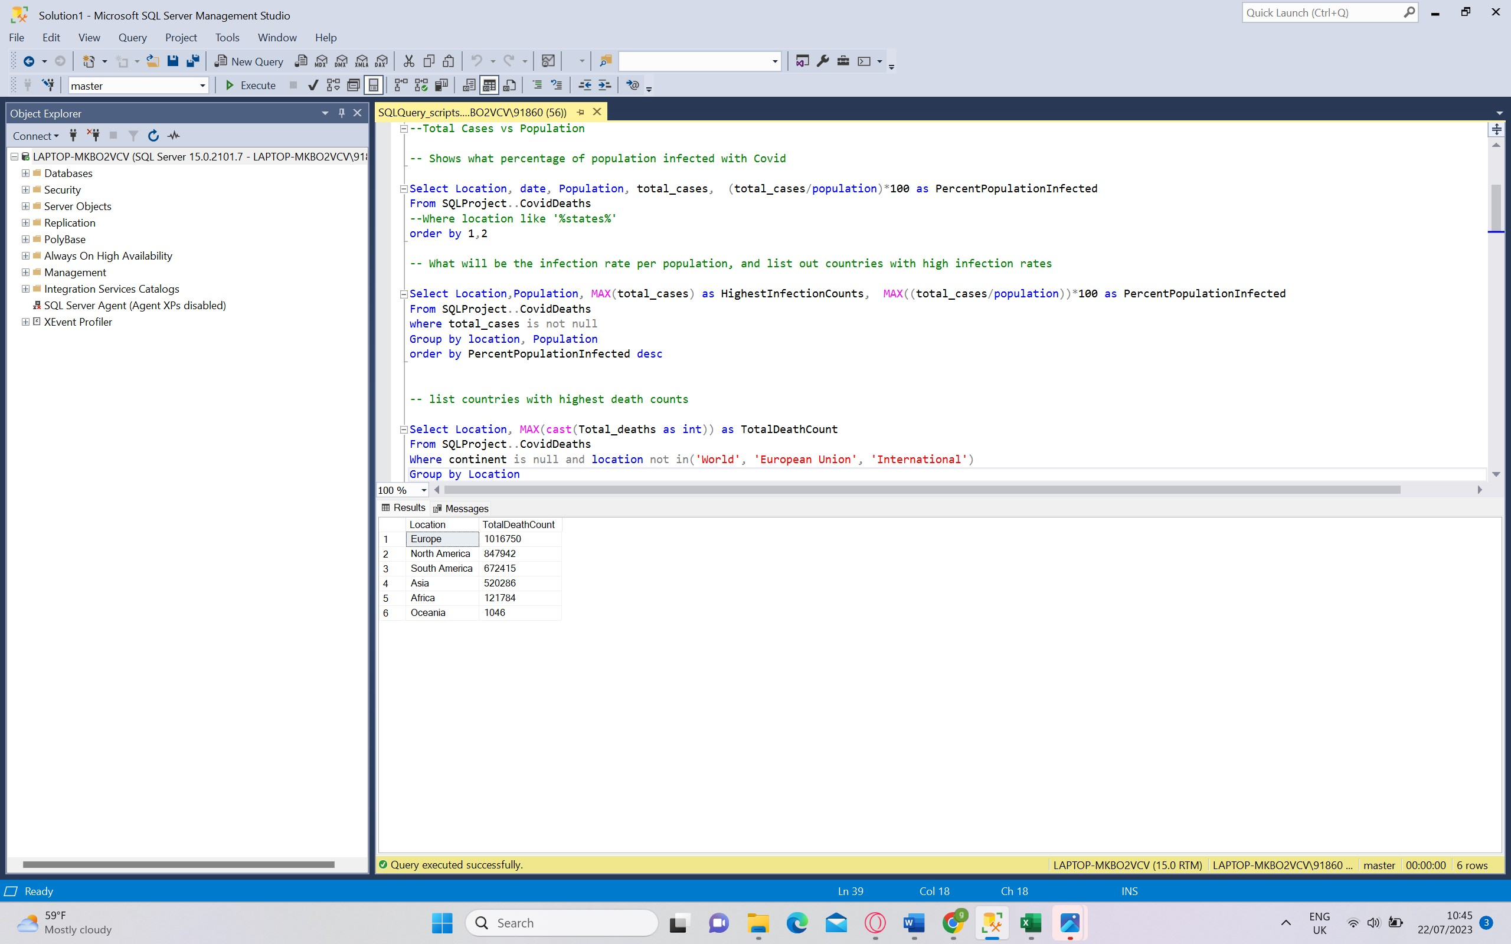

1. Exploring Global Numbers in Covid 19 data set

Select SUM(new_cases) as total_cases, SUM(cast(new_deaths as int)) as total_deaths, SUM(cast(new_deaths as int))/SUM(New_Cases)*100 as DeathPercentage

From SQLProject..CovidDeaths

where continent is not null

order by 1,2.

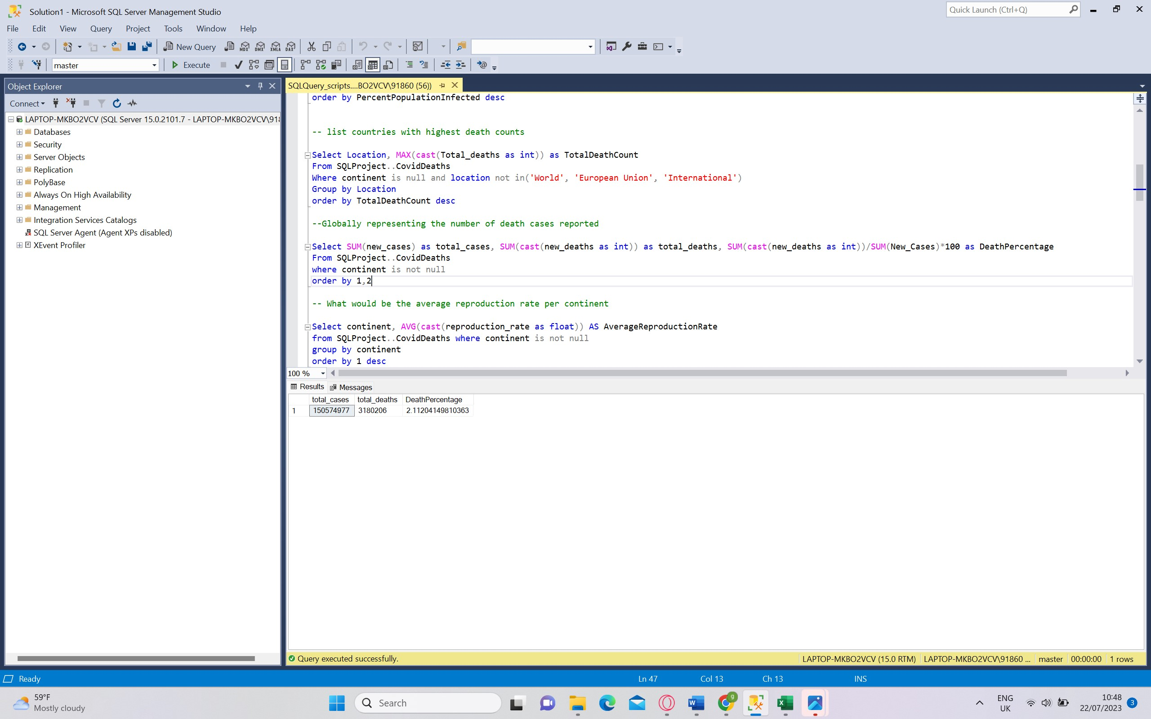

1. Calculate the average stringency index for each year to understand how strict COVID-19 restrictions where in Asia.

select date, location, avg(stringency_index) as AverageStringency

from SQLProject..CovidVaccinations

where iso_code='BTN' and stringency_index is not null

group by date, location

order by AverageStringency

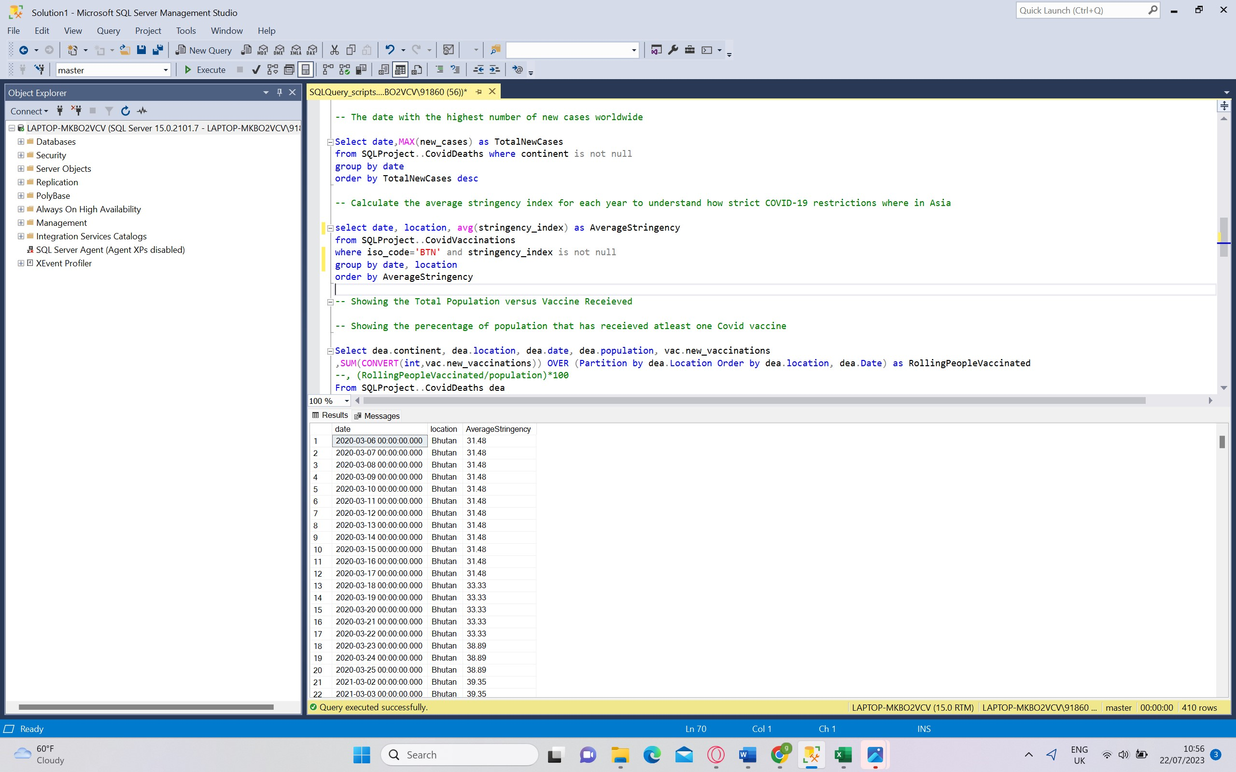

1. Created a temp table to find the Percentage of population who has receieved atleast one covid vaccine

DROP Table if exists PercentPopulationVaccinated

Create Table PercentPopulationVaccinated

(

Continent nvarchar(255),

Location nvarchar(255),

Date datetime,

Population numeric,

New_vaccinations numeric,

RollingPeopleVaccinated numeric

)

Insert into PercentPopulationVaccinated

Select dea.continent, dea.location, dea.date, dea.population, vac.new_vaccinations

,SUM(CONVERT(int,vac.new_vaccinations)) OVER (Partition by dea.Location Order by dea.location, dea.Date) as RollingPeopleVaccinated

From SQLProject..CovidDeaths dea

Join SQLProject..CovidVaccinations vac

On dea.location = vac.location

and dea.date = vac.date

--where dea.continent is not null

--order by 2,3

Select * , (RollingPeopleVaccinated/Population)*100 as PercentagePeopleRollingVaccine

From PercentPopulationVaccinated

